Trump’s Anti-Immigrant Rhetoric Harms U.S. Innovation

Patty Nieberg

As a new race of science and tech unfolds across the globe, developing nations are designing immigration policies to capitalize on skilled talent abroad. The U.S. on the other hand, may fall behind due to the Trump administration’s anti-immigrant sentiment.

In late May, the Trump administration introduced a new “merit-based legalimmigration system” to increase the number of immigrants selected based on skills from 12 to 57 percent. But Trump’s rhetoric may turn talent away and send them elsewhere.

“We shoot ourselves in the foot by putting barriers up to immigration for reasons that really are more ideological than anything,” said Albert Teich, a professor at George Washington University and former Director of Science & Policy Programs at the American Association for the Advancement of Science.

When it comes to science and technology innovation, money is allocated to “Research and Development” or R&D. Many of the top ten R&D-spending nations have implemented skilled-worker visa policies, like the [U.S.](https://www.whitehouse.gov/articles/president-trumps-bold-immigration-plan-21st-century/), [Israel](https://www.timesofisrael.com/15000-tech-worker-shortfall-pushing-firms-to-seek-talent-offshore/), [Germany](https://www.deutschland.de/en/topic/business/the-skilled-labour-immigration-act-working-in-germany) and China.

When measuring R&D, two different categories are used: purchasing power parity and the percentage of GDP. Both tell different stories.

(insert chart to show top 10 r&d spending based on PPP)

According to the UNESCO Institute for Statistics, when looking at PPP, the U.S. leads with $4.76 billion followed by China: $371 billion, Japan: $170 billion, Germany: $110 billion and Korea: $73 billion.

But Nicholas Vonortas, director of the Center for International Science and Technology Policy at GWU, said, “We typically will talk about the percentage [of GDP] than PPP, because countries are so different from each other that to talk about money, doesn’t make much sense.”

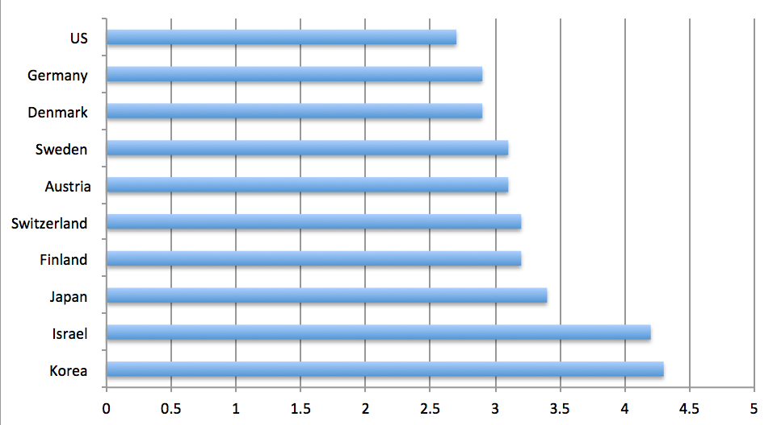

Percentage of GDP going towards R&D

“For example, Sweden spends much higher of GDP on research and yet if you put Swedish money next to the Chinese money it’s like next to zero,” Vonortas said. “That doesn’t mean that Sweden is not trying very hard and it is actually succeeding.”

This is the case in Israel, a country made up of 8.9 million people which spends 4.2 percent of its GDP on R&D, making it second place overall.

According to UNESCO, Israel’s R&D workforce is 77,143 personnel which is relatively small to the other top ten nations. The [Israel Innovation Authority has announced a ten-year program](https://www.dropbox.com/sh/1rzodiz6e7j7l7t/AAApcxdesAZNP6mDkrOE11Qqa?dl=0&preview=2018+Human+Capital+Report.pdf) to fill the gap of 15,000 skilled workers with the most open positions in “Internet - Software” and “Life Science - Clean Tech.”

Similarly, Germany’s [Skilled Labour Immigration Act](https://www.deutschland.de/en/topic/business/the-skilled-labour-immigration-act-working-in-germany), expected to begin in 2020, aims to fill the 1.2 million unfilled jobs which includes a lack of IT specialists, engineers, aerospace, energy and STEM positions.

And in Finland, the [Finnish Startup Permit](https://www.businessfinland.fi/en/do-business-with-finland/work-in-finland/startup-permit/) to allow international entrepreneurs, specifically outside the EU, the chance to build start ups.

And while the U.S. and China have larger economies with billions to invest in R&D across all sectors, for smaller countries, Vonortas said they must choose sectors to focus on: Israel with defense, Sweden with manufacturing, Finland and Denmark with IT.

The real investment of these industries, however, comes from the private sector. For Israel’s R&D for example, 84.6 percent comes from the private sector, which is the highest among all of the leading countries.

(Double Bar graph showing public/private for top 10 nations)

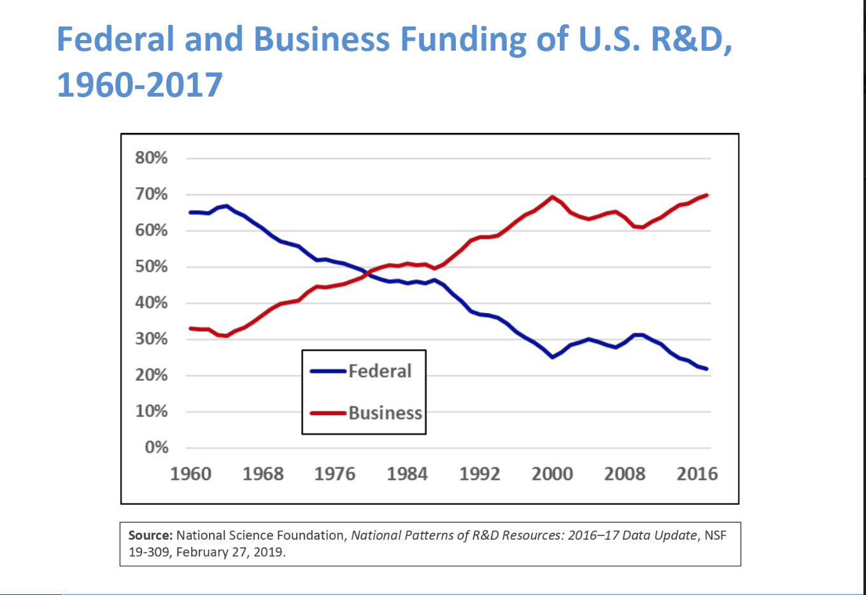

This increase in private sector funds has become a trend in the age of globalization. In the U.S., private sector spending surpassed the public sector in 1980 and has continued to grow since.

In the White House’s 2020 budget, it states that federal government investment in R&D for both energy and cybersecurity will “enable the private sector” to advance their initial research.

As business investment grows, the largest public sector for R&D in the U.S. is defense with [almost $60 million](https://www.whitehouse.gov/wp-content/uploads/2019/03/ap_21_research-fy2020.pdf).

“It’s a lot of development of particular weapons so you have a direct impact and it makes absolute sense because the spender, the government is also the user so they know what they are looking for exactly,” Vonortas said.

The move towards private spending allows for more competition and consumer-driven products.

“This is where countries like China have an easier time,” he said. “They have a political regime that allow them to say this is the tech that we’ll go after and this is the company that is our company.”

In a recent trip to China, Vonortas said the packages that the Chinese government is offering to skilled workers is more attractive: a higher starting position and more money.

The Chinese [R Visa for Highly-skilled Foreign Nationals](http://en.safea.gov.cn/pdf/EvaluationCriteriaforForeignersEmployedinChina%28Trial%29.pdf), calls for those in leading science, technology, R&D, engineering, business and more. And as China becomes more globalized, Vonortas foresees a change in the next five to ten years in their approach -- similar to the [U.S. and Japan dynamic](https://www.npr.org/2019/05/20/725139664/lessons-for-today-from-the-u-s-japan-trade-war-of-the-1980s) in the 1980’s under President Reagan.

With more impediments for skilled workers looking to pursue R&D related fields, Teich said that other English speaking countries like the UK, Canada and Australia will benefit.

Vonortas also echoed that the supply of talented individuals looking to immigrate to the U.S. is important for the economy going forward.

“We need to pay a lot of attention to this visa business and the way we welcome foreigners here. Very few countries can choose who to admit like this, there is more demand for coming in than supply of jobs so we must be very careful with this,” Vonortas said. “Because it may dry up.”